24RP11363

1. Folder 11363_STUDENT_MIS CREATION

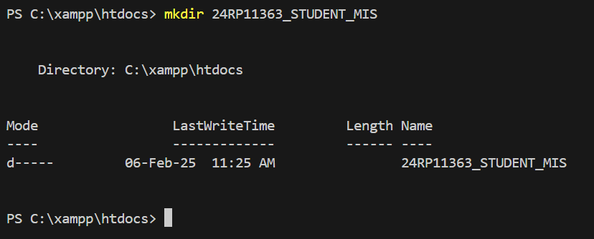

1. Committed “index page is created”

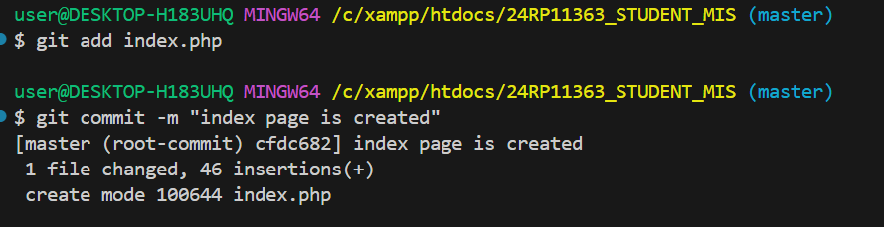

1. Registration page creation with all necessary command and branches

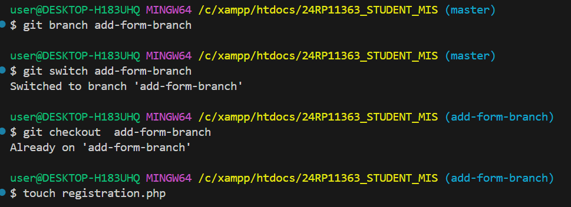

1. Committing changes done in task 3 with “24RP11363, The form is added succesfuly”

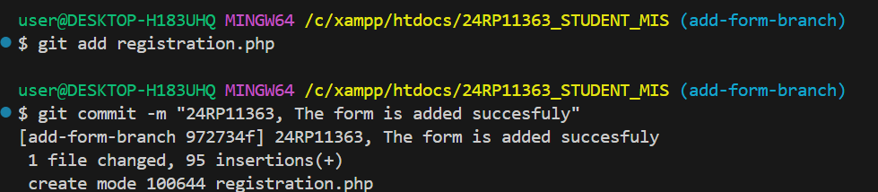

1. Merge registration page to master branch

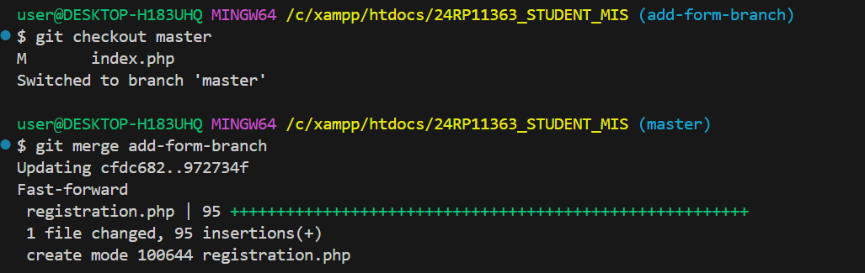

6.